**Paylocity Bug Challenge**

The following defects were found while testing the Bug Challenge "Paylocity Benefits Dashboard".

##### **Defect ID:001**

##### **Summary:** New Employee Add functionality from Paylocity Benefits Dashboard is working inconsistently.

##### **Description:** After providing all the details for a new employee in the Add Employee form, when clicking on Add button, new employee add functionality is not working sometimes. No error message is showing though and user stays in the same Add Employee form. After sometime when logging in again in the application the Add functionality is working fine.

##### **Severity: High**

##### **Preconditions:** Log in using valid credentials.

##### **Test Data: Username:** TestUser156**, Password:** =h9j}o3K}f&u

###### **Steps to reproduce:**

1. Log in using the test data provided.
2. On the "Paylocity Benefits Dashboard" page, click the "Add Employee" button
3. Input Employee First Name, Last Name & Dependents information.
4. Click the "Add" button

###### **Actual Result:**

Sometimes no New Employee is being added after clicking on Add button, though no error message is showing.

###### **Expected Result:**

New Employee should get added with the information provided. The Add functionality should work consistently.

###### **Screenshot:**

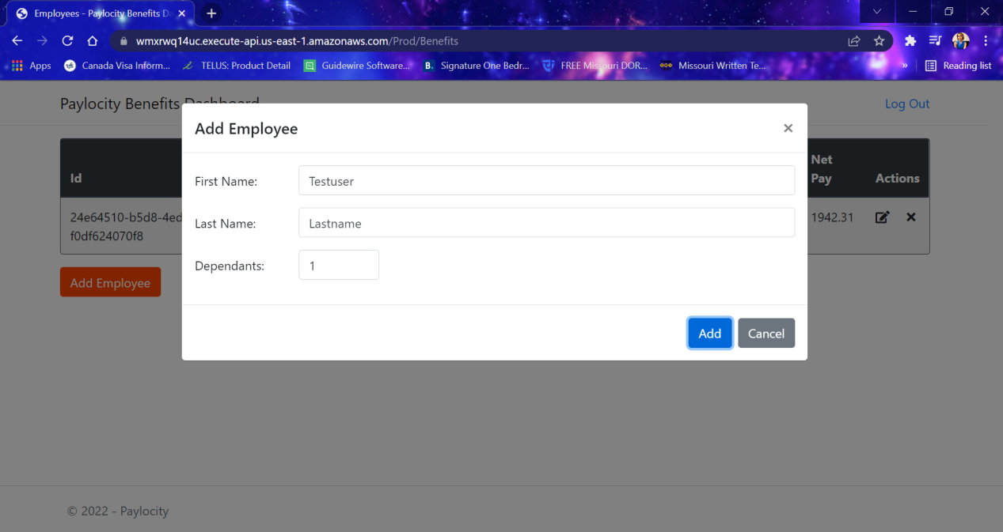

##### **Defect ID:002**

##### **Summary:** No error message is showing when trying to add higher number of dependents in New Employee form on Paylocity Benefits Dashboard

##### **Description:** After providing all the details for a new employee with a higher number of dependents in the Add Employee form, when clicking on Add button, new employee is not being added and no error message is showing saying how many maximum dependents are allowed.

##### **Severity: Medium**

##### **Preconditions:** Log in using valid credentials.

##### **Test Data: Username:** TestUser156**, Password:** =h9j}o3K}f&u

###### **Steps to reproduce:**

1. Log in using the test data provided.
2. On the "Paylocity Benefits Dashboard" page, click the "Add Employee" button.
3. Input Employee First Name, Last Name & Dependents information as 40 or 33.
4. Click the "Add" button.

###### **Actual Result:** No error message is showing stating that more than maximum allowed dependents has been entered.

###### **Expected Result:** An error message should show stating that more than maximum allowed dependents has been entered.

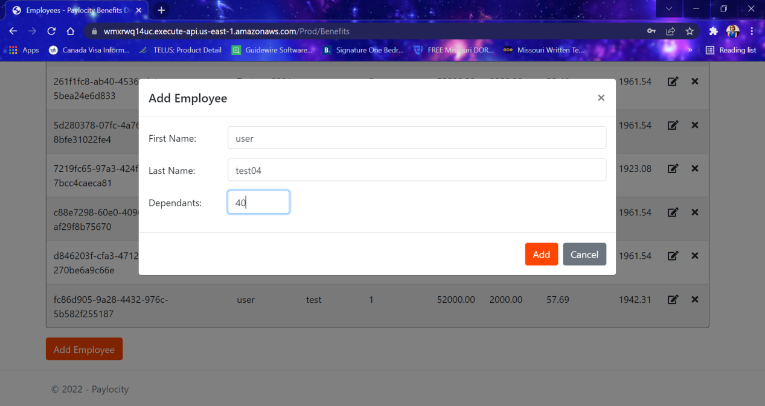

##### **Defect ID:003**

##### **Summary:** Delete Employee functionality from Paylocity Benefits Dashboard is working inconsistently.

##### **Description:** When clicking on Delete icon for a corresponding employee detail,, delete employee functionality is not working sometimes. No error message is showing though and user stays in the same Delete Employee pop up screen. After sometime when logging in again in the application the delete functionality is working.

##### **Severity: High**

##### **Preconditions:** Log in using valid credentials.

##### **Test Data: Username:** TestUser156**, Password:** =h9j}o3K}f&u

###### **Steps to reproduce:**

1. Log in using the test data provided.
2. On the "Paylocity Benefits Dashboard" page, click the "Cross(X)" icon corresponding to a employee. Click on Delete button from the Delete Employee popup screen.

###### **Actual Result:**

Sometimes Delete Employee is not working after clicking on Delete button, though no error message is showing.

###### **Expected Result:** Delete Employee functionality should work consistently.

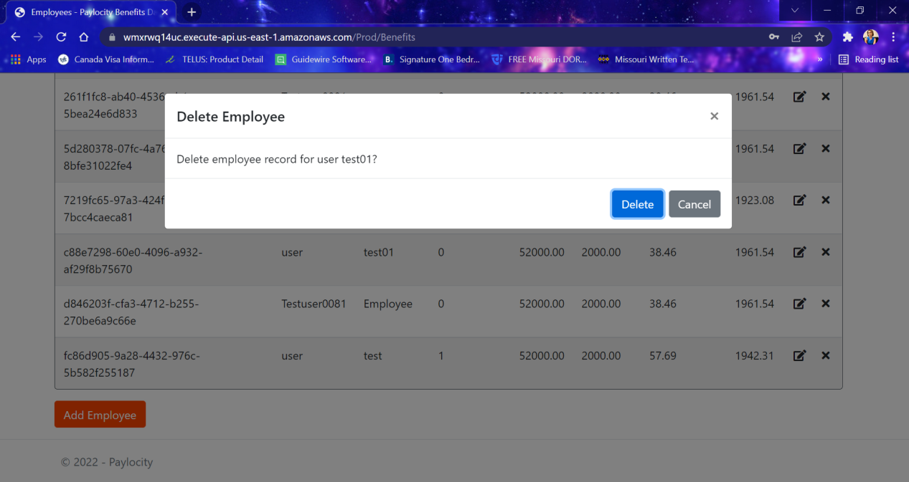

##### **Defect ID:004**

##### **Summary:** First Name and Last Name of the employee is showing under wrong column on Employee list screen

##### **Description:** On the Paylocity Benefits Dashboard screen, employee First Name and Last Name are showing under wrong column name. First name is showing under Last Name column and Last Name is showing under First Name.

##### **Severity: High**

##### **Preconditions:** Log in using valid credentials.

##### **Test Data: Username:** TestUser156**, Password:** =h9j}o3K}f&u

###### **Steps to reproduce:**

1. Log in using the test data provided.
2. On the "Benefits Dashboard" page, click the "Add Employee" button
3. Enter "First" in the "First Name" field
4. Enter "Last" in the "Last Name" field and enter the dependents details
5. Click the "Add" button

###### **Actual Result:**

First Name (First) is showing under Last Name column and Last Name (Last) is showing under First Name column

**Expected Result:** First Name (First) should show under First Name column and Last Name (Last) should show under Last Name column.

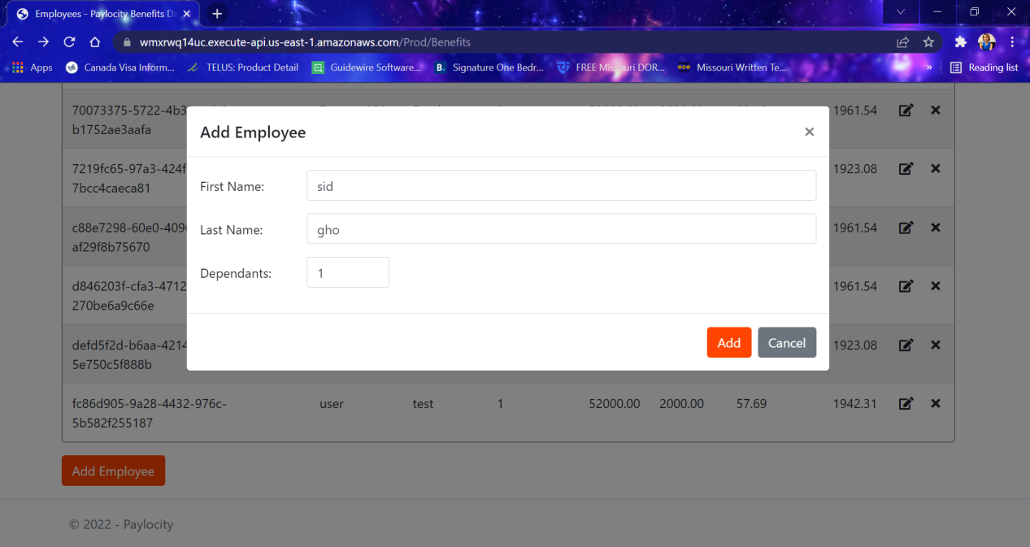

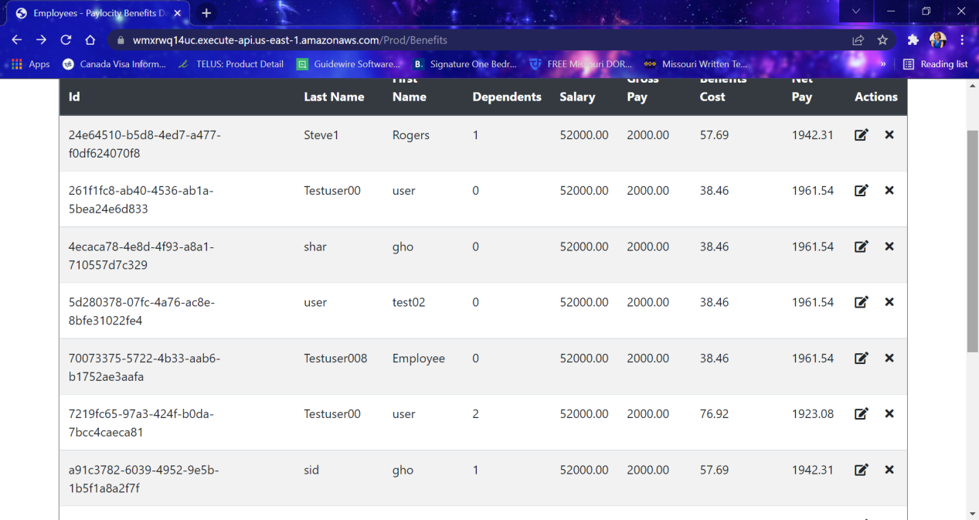

##### **Defect ID:005**

##### **Summary:** First Name and Last Name fields of the Add employee or Edit employee screen are allowing to enter special characters

##### **Description:** While adding and editing employee First Name and Last name fields are allowing to enter special characters.

##### **Severity: High**

##### **Preconditions:** Log in using valid credentials.

##### **Test Data: Username:** TestUser156**, Password:** =h9j}o3K}f&u

###### **Steps to reproduce:**

1. Log in using the test data provided.
2. On the "Benefits Dashboard" page, click the "Add Employee" button or Edit Employee icon
3. Enter special characters (e.g. @#%$!*) in the "First Name" field and in the “Last Name” field
4. Click the "Add"/”Update” button

###### **Actual Result:**

First name and Last name fields are allowing special characters to be entered as employee’s first and last name.

**Expected Result:**

First Name and Last Name fields should not allow entering special characters.

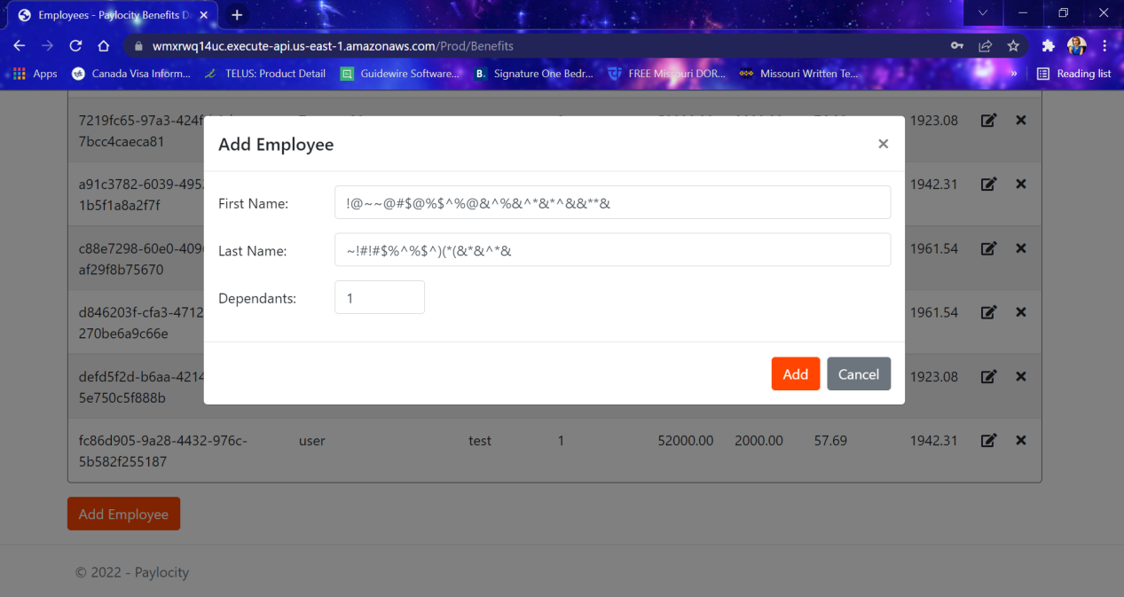

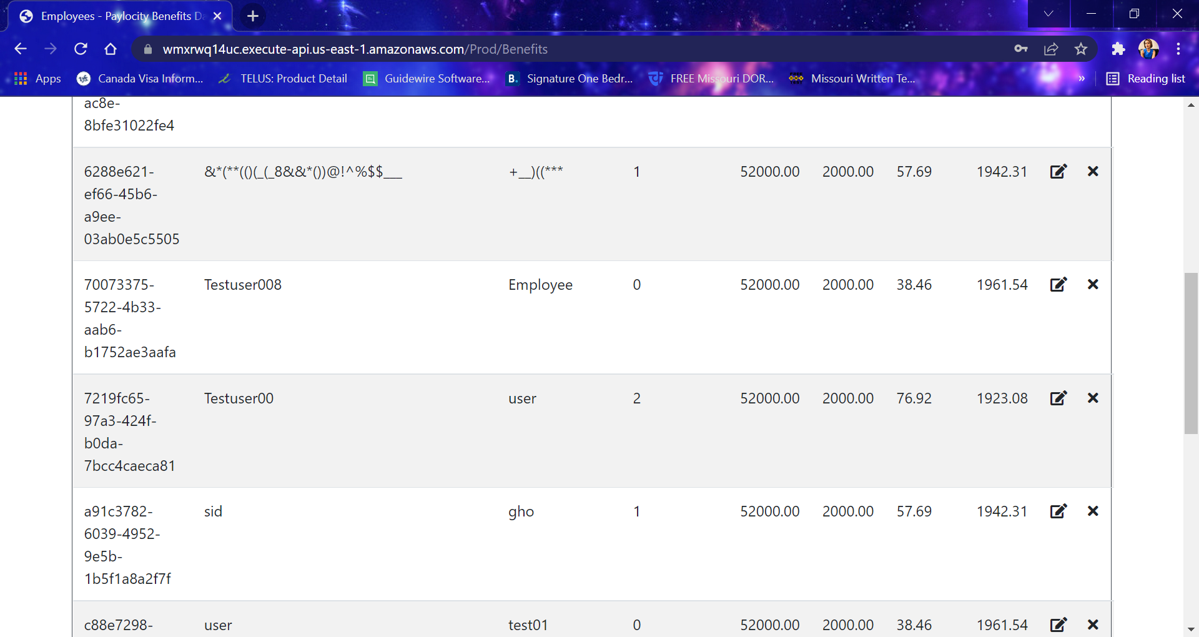



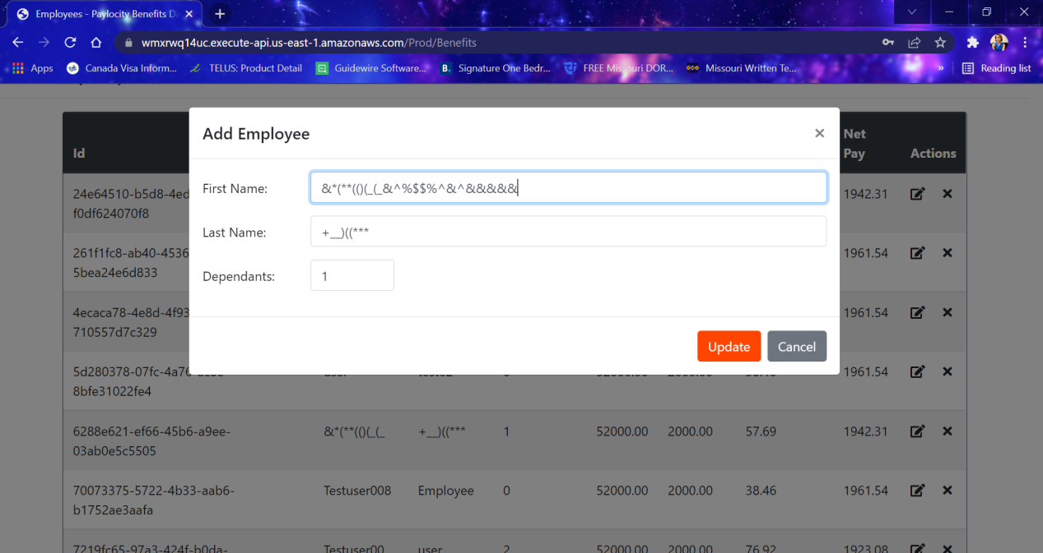

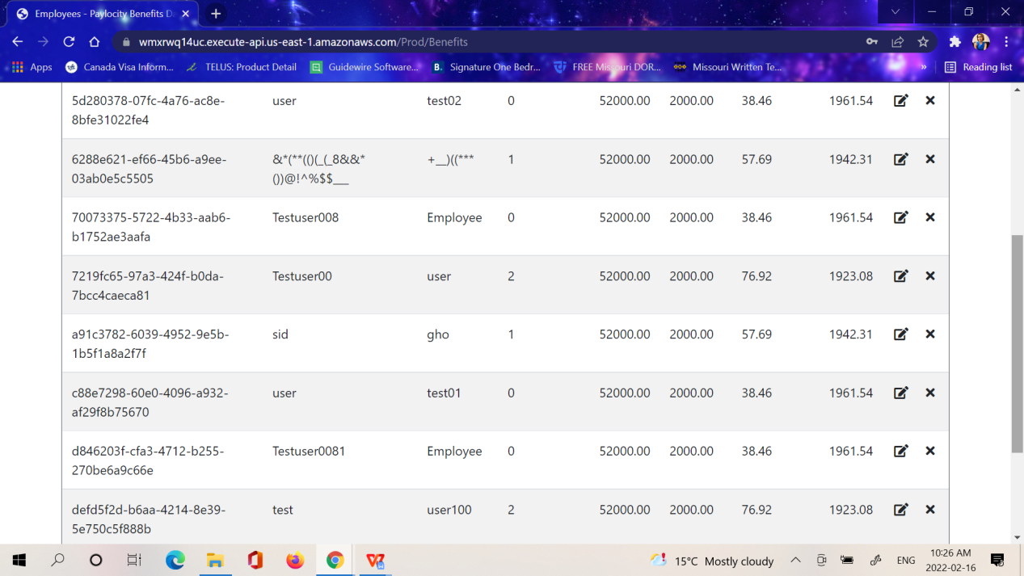

##### **Defect ID:006**

##### **Summary:** First Name and Last Name fields of the Add employee and Edit employee screen are allowing very long characters

##### **Description:** While adding and editing employee, First Name and Last name fields are allowing to enter very long characters.

##### **Severity: High**

##### **Preconditions:** Log in using valid credentials.

##### **Test Data: Username:** TestUser156**, Password:** =h9j}o3K}f&u

###### **Steps to reproduce:**

1. Log in using the test data provided.
2. On the "Benefits Dashboard" page, click the "Add Employee" button
3. Enter very long characters in the "First Name" field and in the “Last Name” field
4. Click the "Add" button

###### **Actual Result:**

First name and Last name fields are allowing very characters to be entered as employee’s first and last name.

**Expected Result:**

First Name and Last Name fields should not allow to enter very long string.

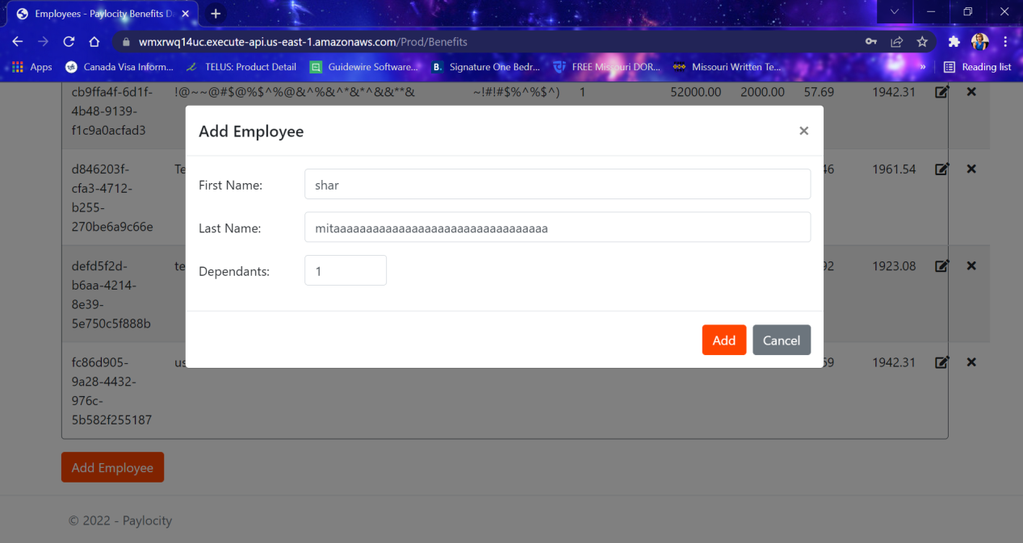

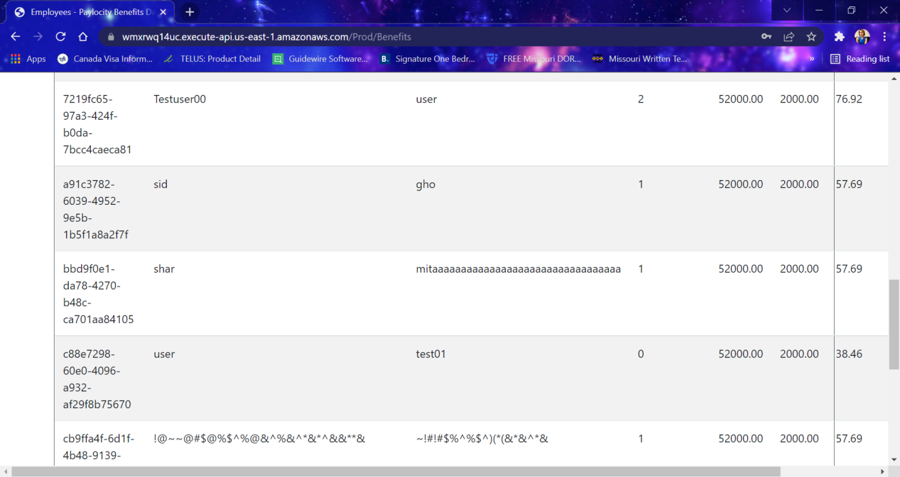

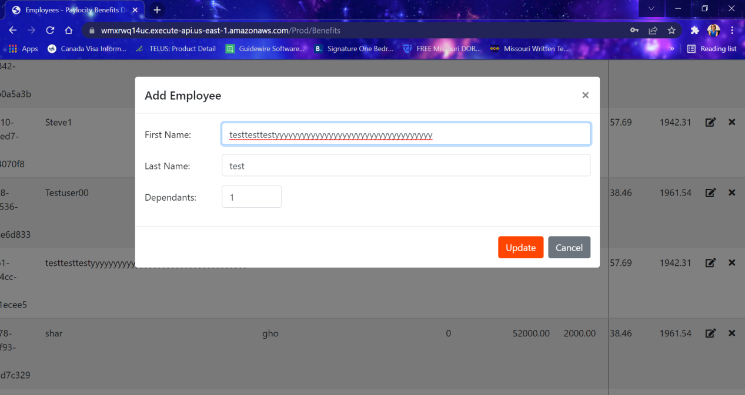

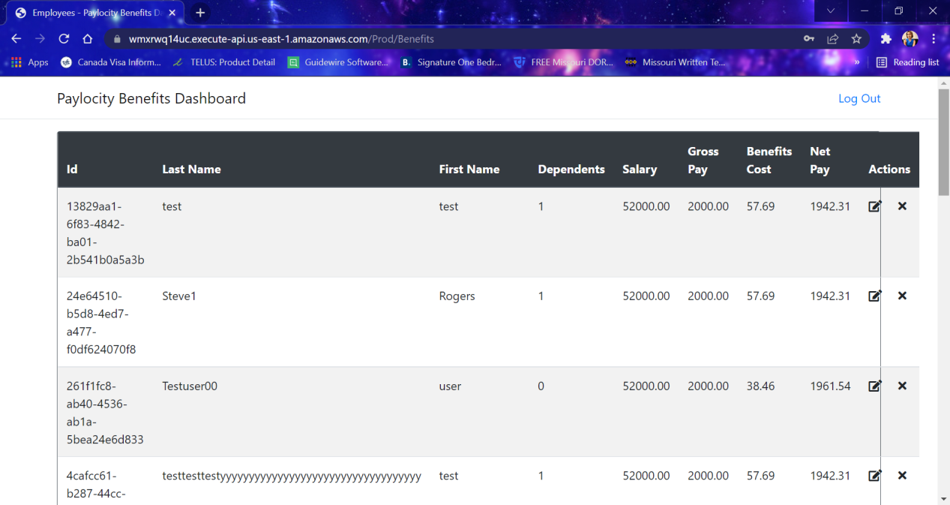

##### **Defect ID:007**

##### **Summary:** Employee list layout on Paylocity Benefits Dashboard is getting distorted

##### **Description:** After adding an employee name with long characters the design of the employee list page is completely distorted.

##### **Severity: Medium**

##### **Preconditions:** Log in using valid credentials.

##### **Test Data: Username:** TestUser156**, Password:** =h9j}o3K}f&u

###### **Steps to reproduce:**

1. Log in using the test data provided.
2. On the "Benefits Dashboard" page, click the "Add Employee" button
3. Enter very long characters in the "First Name" field and in the “Last Name” field
4. Click the "Add" button

###### **Actual Result:**

Design of the Employee list is completely distorted.

**Expected Result:**

Design of the Employee list should be consistent.

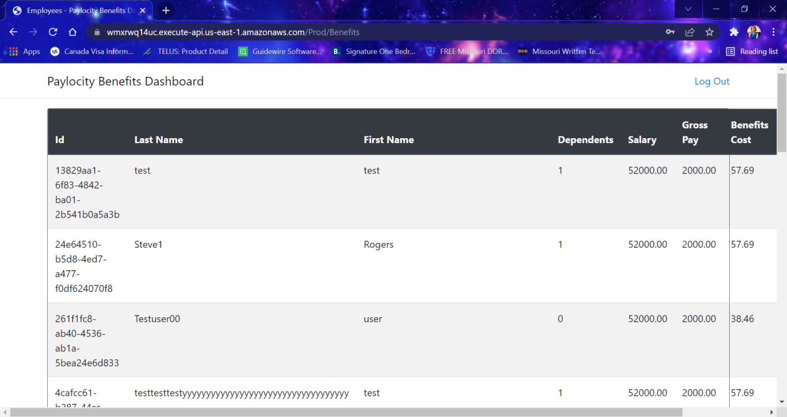

##### **Defect ID:008**

##### **Summary:** User can reach to the blank Employee list screen without being log in.

##### **Description:** After landing on the login screen when clicking on “Paylocity Benefits Dashboard” text user is able to navigate to the blank employee list screen and can click on the Add Employee button as well without being logged in to the system.

##### **Severity: High**

##### **Preconditions:** Launch the Paylocity application url

##### **Test Data:** https://wmxrwq14uc.execute-api.us-east-1.amazonaws.com/Prod/Account/Login

###### **Steps to reproduce:**

1. Launch the Paylocity URL
2. Click on the “Paylocity Benefits Dashboard” text

###### **Actual Result:**

User is able to reach to the Employee list screen (https://wmxrwq14uc.execute-api.us-east-1.amazonaws.com/Prod/Benefits) and also able to click on the Add Employee button and enter the employee details (though final Add functionality is not working).

**Expected Result:**

User should not be able to reach to the Employee list screen (https://wmxrwq14uc.execute-api.us-east-1.amazonaws.com/Prod/Benefits), though its blank, without proper login. Hence should not be able to click on ADD Employee button as well.

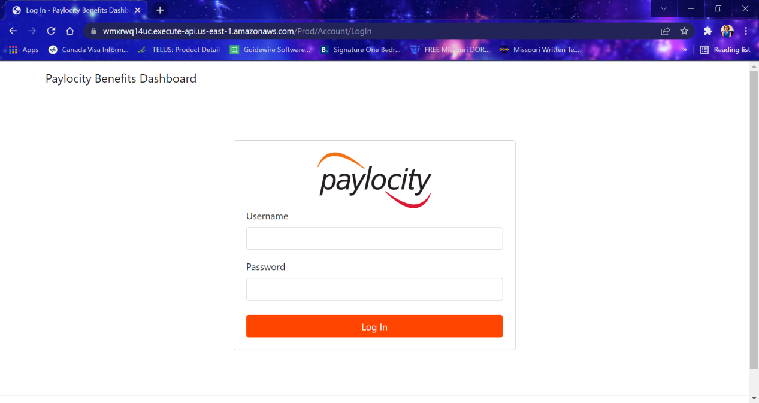

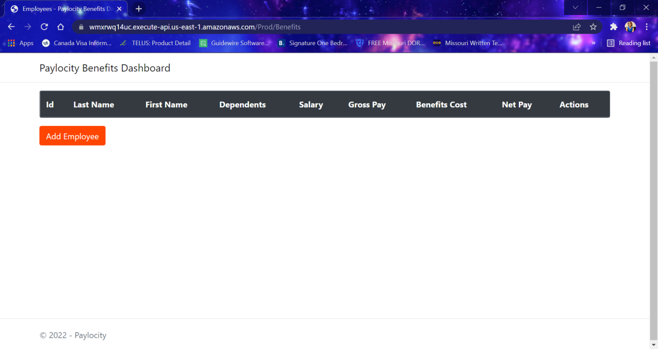

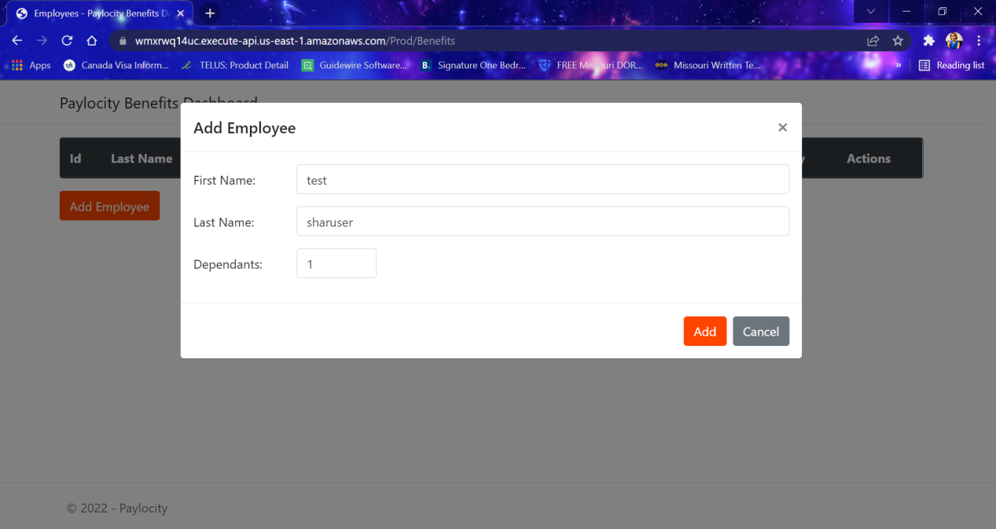

##### **Defect ID:009**

##### **Summary:** In Add Employee and Update Employee API, getting 500 Internal Server error

##### **Description:** While adding or updating an employee under “dependents” of payload (request body) while giving special character as (e.g.“!”) input, showing 500 Internal Server error.

##### **Severity: High**

##### **Preconditions:** Add the API collection to local Postman

##### **Test Data:** Enter “!” for Dependents of the payload

##### **Steps to reproduce:**

1. Open the Add or Update Employee API
2. Give special character for dependents and click on Send

###### **Actual Result:**

500 Internal server error is showing

**Expected Result:**

This should be handled properly like the instance when more than 32 dependents is being entered.

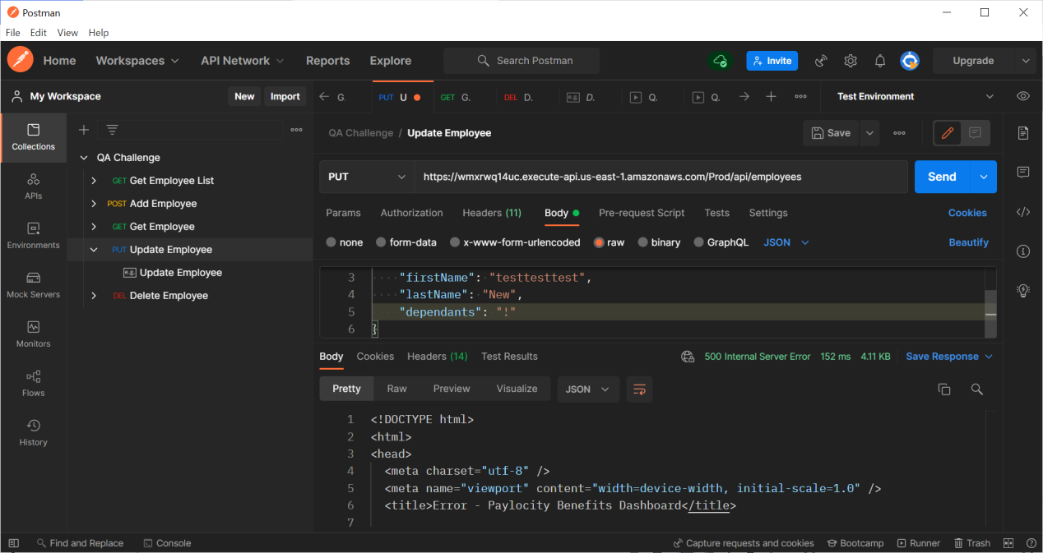

##### **Defect ID:010**

##### **Summary:** While sending request using Update Employee API for an employee which does not exist already “Salary”, “Gross Salary” value in response is “0.0”.

##### **Description:** When sending request using Update Employee API for an employee which does not exist already “Salary”, “Gross Salary” value in response is “0.0”, hence “net” value is coming in Negative.

##### **Severity: High**

##### **Preconditions:** Add the API collection to local Postman

##### **Steps to reproduce:**

1. Open the Update Employee API
2. Under “id” of the payload give a random value which is not already existing in the system (but in the correct format of the id).
3. Give employee first name and last name (employee is not already existing in the system).
4. Add “dependents”
5. Click on Send from postman.

###### **Actual Result:**

A new employee is being added with the given employee name and dependents details. But the “Salary”, “Gross Salary” value in response is “0.0”, hence “net” value is coming in Negative. As a result in the front end of the application, always all benefits details are showing as wrong, no way to correct them. Also the “id” value is the response is changed from the value which was entered in the Update Employee request.

**Expected Result:**

Though we are trying to update an employee which is not already present in the database, “Salary”, “Gross Salary” value in response should be same as Add Employee API response. i.e. “Salary”- 52000.00 “Gross Salary”- 2000.00.

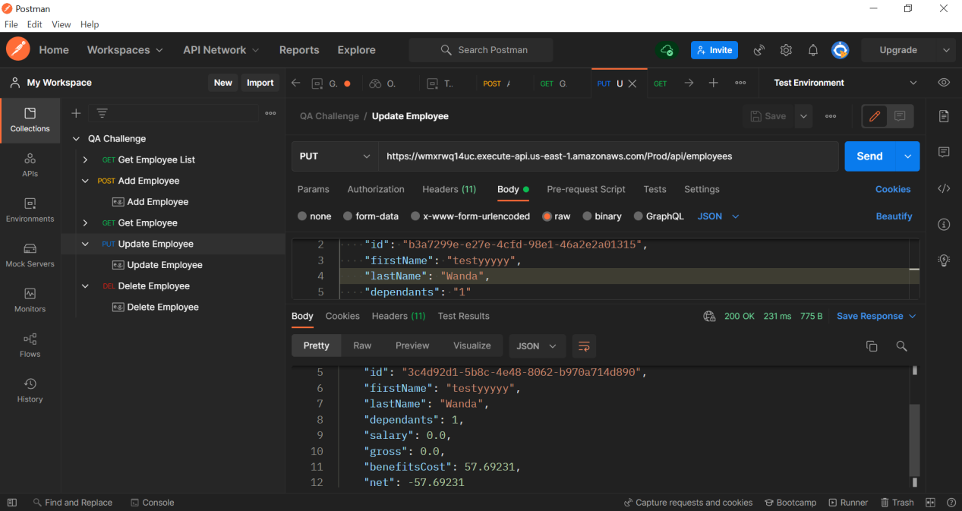

##### **Defect ID:011**

##### **Summary:** Employee Edit functionality from Paylocity Benefits Dashboard is working inconsistently.

##### **Description:** After changing all the details for an existing employee, when clicking on Update button, existing employee edit functionality is not working sometimes. No error message is showing though and user stays in the same form. After sometime when logging in again in the application the Edit functionality is working fine.

##### **Severity: High**

##### **Preconditions:** Log in using valid credentials.

##### **Test Data: Username:** TestUser156**, Password:** =h9j}o3K}f&u

###### **Steps to reproduce:**

1. Log in using the test data provided.
2. On the "Paylocity Benefits Dashboard" page, click the "Edit" icon.
3. Change the Employee First Name, Last Name & Dependents information.
4. Click the "Update" button.

###### **Actual Result:**

Sometimes no modification is being done after clicking on Update button, though no error message is showing.

###### **Expected Result:**

Employee information should get modiffied with the information provided. The Edit functionality should work consistently.

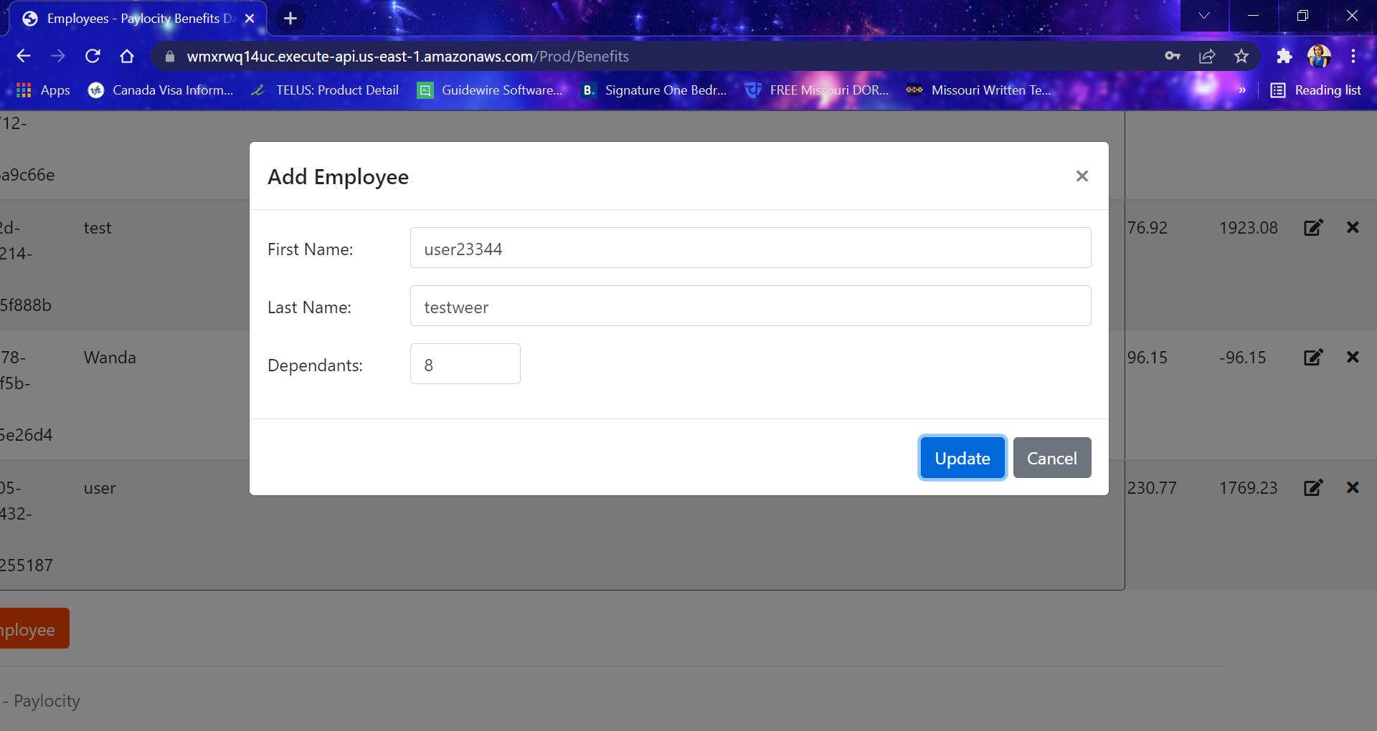

##### **Defect ID:012**

##### **Summary:** Employee Edit screen title is wrong.

##### **Description:** Edit Employee screen title is showing as “Add Employee”.

##### **Severity: Low**

##### **Preconditions:** Log in using valid credentials.

##### **Test Data: Username:** TestUser156**, Password:** =h9j}o3K}f&u

###### **Steps to reproduce:**

1. Log in using the test data provided.
2. On the "Paylocity Benefits Dashboard" page, click the "Edit" icon.

###### **Actual Result:**

Edit Employee screen title/heading is showing as “Add Employee”.

###### **Expected Result:**

Edit Employee screen title/heading should display as “Edit Employee”.

